<https://github.com/boboppie/coursera-course-statistics_one>

**LECTURE 5 – Measurements**

**Segment 1: Reliability and Validity**

* Reliability:
  + Classical test theory: X = true score + bias + error
  + Three methods to estimate reliability:
    - Test/re-test: measure twice X1 and X2 (won’t reveal the bias)
    - Parallel tests: measure with two elements at the same time (X1 and X2) it reveals the bias
    - Inter-item: most common used. Randomly pick subsets of items and correlate them.
* Validity:
  + A construct: is an idealized object (not directly observed)
  + Construct validity:
    - Content validity
    - Convergent validity
    - Divergent validity
    - Nomological validity

**Segment 2: Sampling**

* + Sampling error: difference between population and sample.
  + Standard Error (SE)
    - **SE = SD/√(N)** 🡪 the bigger the simple lower the SE
  + Probability histograms
    - Take multiple samples of the same size and then plot the sample means
    - Distribution of sample means:
    - The mean and The variance is influenced by the sample size Ꝺ2 (population) SD2 (sample)

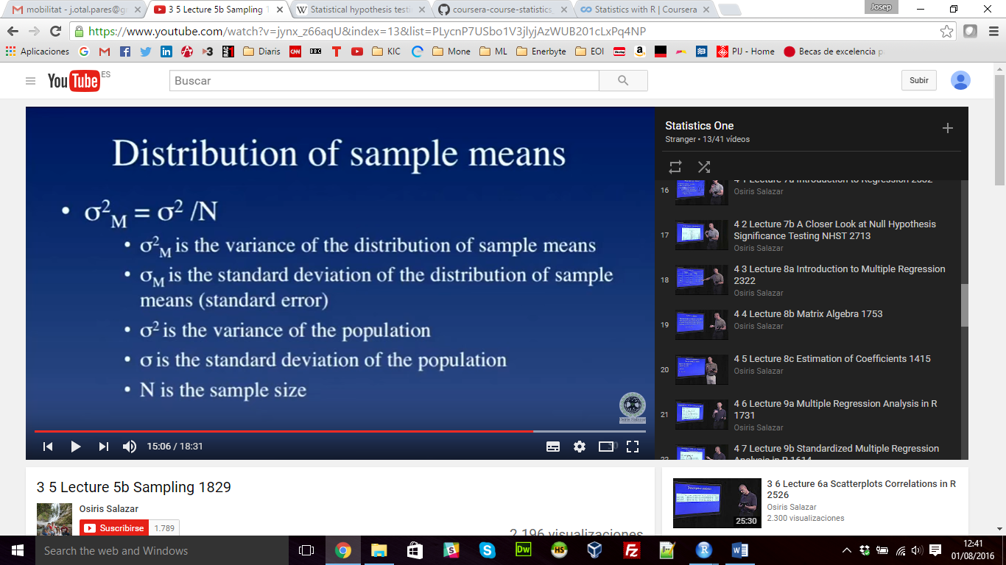

* + **Central Limit Theorem:**
    - Principle 1: mean of the distribution of sample means is the same as the mean of the population
    - Principle 2: the standard deviation of the distribution of the samples means is the square root of the variance of the distribution of sample means, which is ꝹM2 = Ꝺ2/N
    - Principle 3: the shape of the distribution of the sample means is approximately normal if either N >= 30 or shape of the population distribution is normal